Software Development Plan (Small Project)

Upgrade of Existing AKIPRO Software

Version 2.0

November 23, 2014

AKIPRO

Usha Mungal – Moniece Forbes-Wells – Kris Chinaikan- Rohini Cynthia Baboolal

Revision History

|  |  |  |  |
| --- | --- | --- | --- |
| **Date** | **Version** | **Description** | **Author** |
| 15/Sept/14 | 1.0 | First draft | UshaMungal, Moniece Forbes-Wells  Kris Chinaikan |
| 24/Nov/2014 | 2.0 | Final document | Usha Mungal, Moniece Forbes-Wells  Kris Chinaikan  Rohini Cynthia Baboolal |

Table of Contents

1. Introduction 3

1.1 Purpose 4

1.2 Scope 4

1.3 Definitions, Acronyms, and Abbreviations 5

1.4 References 5

1.5 Overview 5

2. Project Overview 6

2.1 Project Purpose, Scope, and Objectives 6

2.2 Assumptions and Constraints 7

2.3 Project Deliverables 7

2.4 Evolution of the Software Development Plan 8

3. Project Organization: 8

3.1 Organizational Structure 8

3.2 External Interfaces 9

3.3 Roles and Responsibilities 10

4. Management Process 12

4.1 Project Estimates 12

4.2 Project Plan 12

**Phase Plan** 12

**4.2.1** **Releases** 13

**4.2.2** **Project Schedule** 14

**4.2.3** **Project Resourcing** 14

4.3 Project Monitoring and Control 15

5. Annexes 16

Software Development Plan (Small Project)

# 

# Introduction

This project is being undertaken to establish an advancement of the AKIPRO software. This new software will aim to support mobile devices in order to promote remote access to customers and employees. The project is to commerce on Monday, September 15, 2014 and will complete no later than Thursday, November 27, 2014.

AKIPRO’s Project involves a transformation of the division’s current predominantly desktop-based framework to a web-empowered result that is better aligned with the company’s goals, improving quality of care with increased proficiency and accuracy. This software is being redesigned to take advantage of the latest features of the 21st century to help the company have the competitive advantage over its competitors. It will employ emerging technologies to help manage the volume of the goods being produced by the company and also its customer and suppler accounts. AKIPRO v1.0 was prototyped as an initial stage towards demonstrating what such a computerized solution would involve.

A team of SE students composed and designed AKIPRO’s v1.0 as part of their SE Project under the guidance of Dr. Wayne Goodridge whom is the producer of the current system and also the facilitator of the course and Mr. Nicholas Singh.

## Purpose

* To architect and implement a prototype visualization application that outlines and documents :-
* Purchase orders
* Customer accounts
* Order processing
* To facilitate efficiency and effectiveness in the information captured and represented with the use of the application and user control access.

## Scope

This v1.0 of AKIPRO system is a proof of conception. However, it is not proposed to be a creation quality application which could be deployed without further testing by the IT staff and end users. This variant incorporates the accompanying modules:-

* Order Processing
* Production Management
* Customer Accounts
* Collection Management
* Adjustments
* Purchase Orders
* Delivery Management
* Sales Representative

The peculiarities included in AKIPRO’s v1.0 may be liable to further upgrades and/or changes in subsequent versions.

## Definitions, Acronyms, and Abbreviations

|  |  |
| --- | --- |
| Term | Description |
| SE | Software Engineering |
| AKIPRO | This is the name of the bakery company whom produce bread and pastries for the Barbados island. |
| Desktop-based | This means that the software is only accessible via a software on the computer system. |
| Web-empowered | This means that the application should be available online. Staff and customers should be able to login with their credentials and view their information |

## References

For the AKIPRO Software Development Plan, the list of referenced artifacts includes:

* Iteration Plans
* Development Cases
* Vision
* Glossary
* Any other supporting plans or documentation.

## Overview

This development plan defines the AKIPRO software development project and the approach taken by the project team to deliver AKIPRO v1.0. This document begins with the introduction which is broken into further subcategories that is the project, it purpose, scope, the definitions and acronyms used in the document and the references associated with the project.

The “Project Overview” subdivision documents the business needs for AKIPRI and the proposed result that’s AKIPRO offers. It gives a concise overview of the features included in AKIPRO Software Development Plan v1.0, its building design and the deliverables of the AKIPRO project.

The “Project Organization” subdivision details the organizational structure, external interfaces and the roles and responsibilities adapted by the AKIPRO team to fulfil the project objectives.

The “Managerial Process” details the project estimates, the project plan and monitoring and control.

This report ends with “Annexes” which has all the additional materials of use to the reader and also references or any of the project technical standards and plans which apply to the AKIPRO Software Development Project.

# Project Overview

## Project Purpose, Scope, and Objectives

This project is based on a company called Aki Bakery Services, which is based in Barbados. The purpose of this project is to update the present system that is being used by the company which was put into place in the year 2000. This new system is scheduled for completion by the end of the year 2014. The company is looking to improve its services and management of its products by having its system remodeled so as to allow for access to the system by their employees and their customers through better means and to keep up with new technologies. The improvements that will be made would be that of allowing for system access through multiple types of devices as well as different interfaces such as Android, iOS, tablets, and mobile devices. These improvements would be made possible due to the fact that the new updated system would be moved from a desktop system based in the company to a web based system that would be easily accessible from the internet via a wireless internet connection that would be linked to the server that would contain the system.

Upon completion of this project, the system would include:

* A module which allows drivers to download orders to mobile devices
* A module which allows drivers to print invoices and monitor returns
* A module to allow merchandisers to monitor and alter standing orders and indicate if any problems exist with products
* A module which allows for customers to have log-in accounts with all necessary information. E.g. returns, standing orders, and fees due.
* A system improvement so as to allow for access to the system from different types of devices via the internet.

## Assumptions and Constraints

* It is assumed that all necessary personnel are available and trained
* It is assumed that feasibility studies and reports have been done and made
* It is assumed that all necessary finances have been allotted and received
* For this project time is a general constraint
* Not being able to observe the actual day to day working of the business is a constraint
* Not being able to see how different processes within the business are done is a constraint
* The lack of documentation of the current system can be considered a constraint since persons requiring these documents for analysis to understand the current system would have them at their disposal.

## Project Deliverables

The listing of deliverables for this project would be that of:

* The Software Development Plan – Delivery date: 03/10/14
* The Requirements Documentation – Delivery date: To be determined
* Specifications Document with Test Cases – Delivery date: To be determined
* Evaluation Report and Prototype – Delivery date: To be determined
* Training Manual with Training Sessions – Delivery Date: To be determined

## Evolution of the Software Development Plan

|  |  |
| --- | --- |
| **Deliverable:** | **Date:** |
| Software Development Plan (Version 1) | 03/10/14 |
| Software Development Plan (Version 2) | 24/11/14 |
| - | - |

# Project Organization:

This subdivision describes the organizational structure, external interfaces and the roles and responsibilities of the individuals on this project. This section gives a better understanding of the external interfaces associated with the project, how the AKIPRO Software Development team divided workload to meet the given requirements and also the roles undertaken by the team members to ensure that the given requirements were met.

## Organizational Structure

Our team basically consists of three individuals.

* Moniece Forbes-Wells
* Kris Chinaikan
* UshaMungal

The review authorities associated with our team are:

* Dr. Wayne Goodridge
* Mr. Nicholas Singh

## External Interfaces

The following are the external groups associated with the project:

1. Customers: Customers are one of the main external entities since they are the prime consumers of the business goods. We engage with them through the medium of face to face contacts and phone calls.
2. Suppliers: Suppliers are the entities that provide the business with the raw materials necessary to produce the good. Therefore suppliers are very pertinent to the business and must always be contacted to places orders or make adjustments to business orders. They are contacted through emails, phone calls and face to face communication.
3. Merchandizers: These are representatives from the bakery that will visit the stores that sells their products to ensure that proper advertising is done and the products are well stocked.
4. Bank: The bank is important since it has a large part to play when it comes to the monetary transactions especially the large monetary transactions (large orders that are paid by wiring money from the bank to the business’s account).
5. Government: Government it important since their rules and regulations can impact the bakery positively or negatively.

The project team members interface with external groups through face to face communication, emails and phone calls.

## Roles and Responsibilities

|  |  |
| --- | --- |
| **Person** | **Rational Unified Process Role** |
| Moniece Forbes-Wells | Contribution to Project plan document:  **Introduction:**   1. purpose 2. scope 3. Definitions/Abbreviations/acronyms 4. References 5. Overview   Moniece will also assume the roles of a system analyst, system designer and a general reviewer. |
| Kris Chinaikan | Contribution to Project Plan document:  **Project Overview:**   1. Project Purpose, Scope, Objective 2. Assumptions and constraints 3. Project Deliverables 4. Evolution of Software Development plan   Kris will also undertake the roles of a system analyst, system designer and a general reviewer. |
| UshaMungal | Contribution to Project Plan document:  **Project Organization:**   1. Organizational Structure 2. External Interfaces 3. Roles and Responsibilities   Usha will also adopt the roles of a system analyst, system designer and a general reviewer. |
| Rohini Cynthia Baboolal | Contribution to Project Plan document:  **Management Process:**   1. Project estimates 2. Project Schedule 3. Project Resourcing   Rohini will also assume the roles of a system analyst, system designer and a general reviewer. |
| All team members | Contribution to Project Plan document:  The team will collaborate in order to achieve the required output of the management process and annexes section of the project plan. I.e.   1. Project plan 2. Phase plan 3. Releases 4. Project Monitoring and control |

# Management Process

## Project Estimates

The Project estimate is shown in The Project Schedule section 4.2.2. The project cost will be updated after the Software Implementation & Testing phase has been completed and if changes are to be made.

## Project Plan

### **Phase Plan**

This project is to be completed in four phases:-

1. Software Requirements Development
2. Software Design
3. Software Implementation
4. Software Testing

* **Software Requirements Development**

This was perhaps the most important phase of this project thus far. In the duration of this phase, weekly meetings were conducted with Dr. Wayne Goodridge to find out specifically the requirements of the project. Use cases and requirement documents are to be prepared in later versions of to be able to properly document the user’s requirement, in which they would be viewed later by Dr. Goodridge.

It is important note however, that communication was a serious issue in this phase. Understanding the client’s needs is very vital to the success of the software development project. The team utilized many different strategies to handle this such as asking the same questions in multiple ways and writing minutes at every meeting. The deliverables which would be produced at the end of this phase are user cases and requirements documents.

* **Software Design**

After the team has finished analyzing the user’s requirements, they would start working on the system design. At this phase, database design and test cases would be determined and a detailed design would be generated which would be used to develop AKIPRO system. Entity Relationship diagrams and system design are two deliverables which would be delivered at the end of this phase.

### **Releases**

First Release:

The first version of this system was called AKIPRO which was released in 2004 to be utilized by the bakery for its transaction processing needs. This system was designed to handle order processing, customer accounts, adjustments, production management, purchase orders and collection management. However, the bakery would now like to implement delivery management, a customer web application and a sales representative application. Therefore a new version of the product has to be designed and released for use by the bakery.

### **Project Schedule**

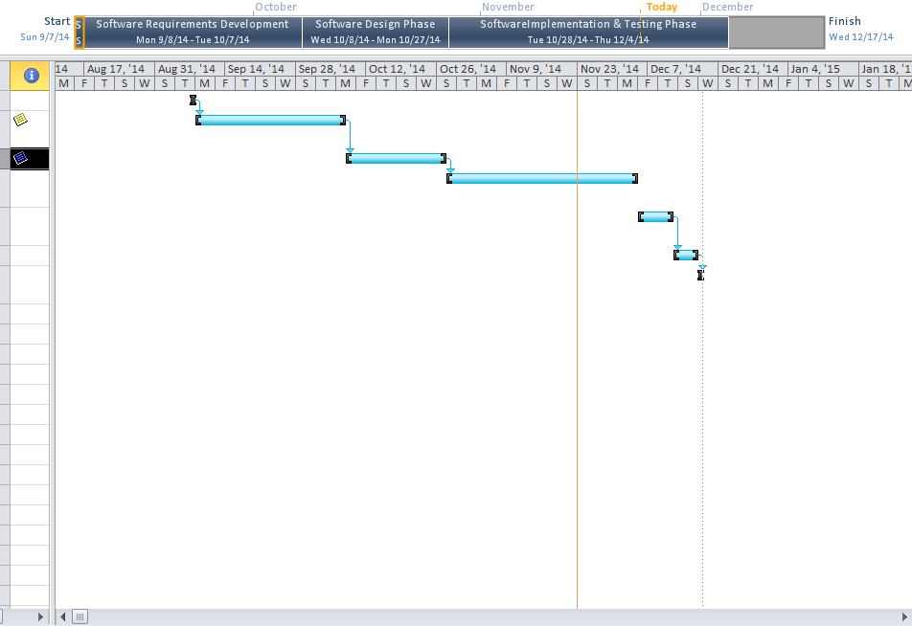

**Fig 1:- Project Schedule**

### **Project Resourcing**

* GitHub
* 4 Laptops
* 4 Team members
* Software applications such as (Microsoft word, Microsoft Project, Pencil)
* At least 2Mb speed internet Access

## Project Monitoring and Control

AKIPRO project team was very much small in size however, a tailored mechanism to monitor and control the progression of the project needed to be implemented because of the time constraints and complexity of each team member. The mechanisms implemented were:-

* Project internal server: - The AKIPRO project team used github server to communicate and document all versions and also to update task. One member created a repository and granted access to the other members so everyone can view and upload their respective portions of the project.
* Frequent client meetings: - the team had the opportunity to communicate with Dr. Wayne Goodridge to be in sync with the needs of the client. Mr. Nicholas Singh was and will be consulted with respect to the implementation of the various diagrams to be implemented in the requirement documents which will be later developed at a later version of the AKIPRO software development project.
* Microsoft Project was used to create a Gantt chart which ensured that each phase was completed within the expected finish date.

**Risk Management**

The key goal to the AKIPRO software development project is managing and minimizing the risks in AKIPRO system. Requirements gathering, design and implementation of the project were evaluated at each phase with the addition of team members collaborating and anticipating the risks which can be encountered through the development of the project. Some of these risks include:-

|  |  |  |
| --- | --- | --- |
| Rating of risk | Risk Description | Solution |
| High | Unclear understanding of the project objectives | the team managed this risk by communicating with Dr. Goodridge during the requirements gathering phase |
| High | Strategizing and maintaining the schedule | A detailed breakdown of tasks was made and allocated accordingly |
| High | Loss of related documents | Github was used to ensure proper documentation which allowed the team easy access to upload, modify or finalize various sections of the project. The collaboration of this software was realtime |
| High | Schedule control | A Gantt Chart was used to keep the 4 team members in track with regards to the due dates for each phase of the application. |
| High | Budget control | Resources were sourced at different locations comparing its cost and quality for the most effective to be used. |
| Medium | Building a user friendly application | Interactions were conducted with several customers and feedback was obtained. Necessary changes were made to ensure that the application is user friendly. |

# Annexes

[Additional material of use to the reader of the **Software Development Plan**. Reference or include any project technical standards and plans which apply to this project. This typically includes the Development Case, plans for infrastructure, and product acceptance. It also typically includes Programming Guidelines, Design Guidelines, and other process guidelines. The text that follows is provided as an example.]

The project will follow the RUP for Small Projects process, as tailored by the project Development Case.

Other applicable process plans are listed in the references section, including Programming Guidelines.